BRAILLE BOX AUTHORING APP

EECS 2311

Team 9

USER MANUAL

JEREMY WINKLER (214 915 854)

NISHA SHARMA (213 251 830)

TYLER THOMSON (215 081 904)

# **TABLE OF CONTENTS**

**TABLE OF CONTENTS**1

0. Version Information 2

1. Initial Setup 2

2. Scenarios 2

3. Graphical User Interface 3

3.1. Main Menu 3

3.2. Creating a New Scenario 4

3.2.1. The Authoring App 5

3.2.2. Prompt 6

3.2.3. Cells 7

3.2.4. Buttons 8

3.2.5 Editing a Scenario 9

3.2.6. Order 10

3.2.7. Audio Recording 11

3.3. Editing a Scenario 13

3.4. Saving a Scenario 14

3.5. Testing a Scenario 15

3.6. Exiting the Application 16

4. Keyboard Shortcuts 17

5. Uninstallation 18

6. Troubleshooting 19

## **0. Version Information**

This is the final release of the application and it’s documentation.

## **1. Initial Setup**

After downloading the zipped folder to a known directory on your computer, simply unzip the folder and navigate to the file **AuthoringApp.jar,** double click to launch the initial window. The app is compatible with up to date Windows, Linux/Unix, and macOS computers running the most current edition of java. In addition, the application is compatible for the visually impaired using Screen Readers supported on NVDA, VoiceOver, and ORCA for Windows, macOS, and Linux respectively.

## **2. Scenarios**

For this application, we’ve broken the components of each scenario into “**Cards**”, each scenario is made up of sequences of Cards, which in themselves can consist of a prompt or question, an audio file if wished, and buttons with possible answers and paths to the given question.

## 

## **3. Graphical User Interface**

## 3.1. Main Menu

Upon launching the application, the user will be met with the main menu, from this menu they will be able to create a new scenario, edit a pre-existing scenario, or test run a scenario.

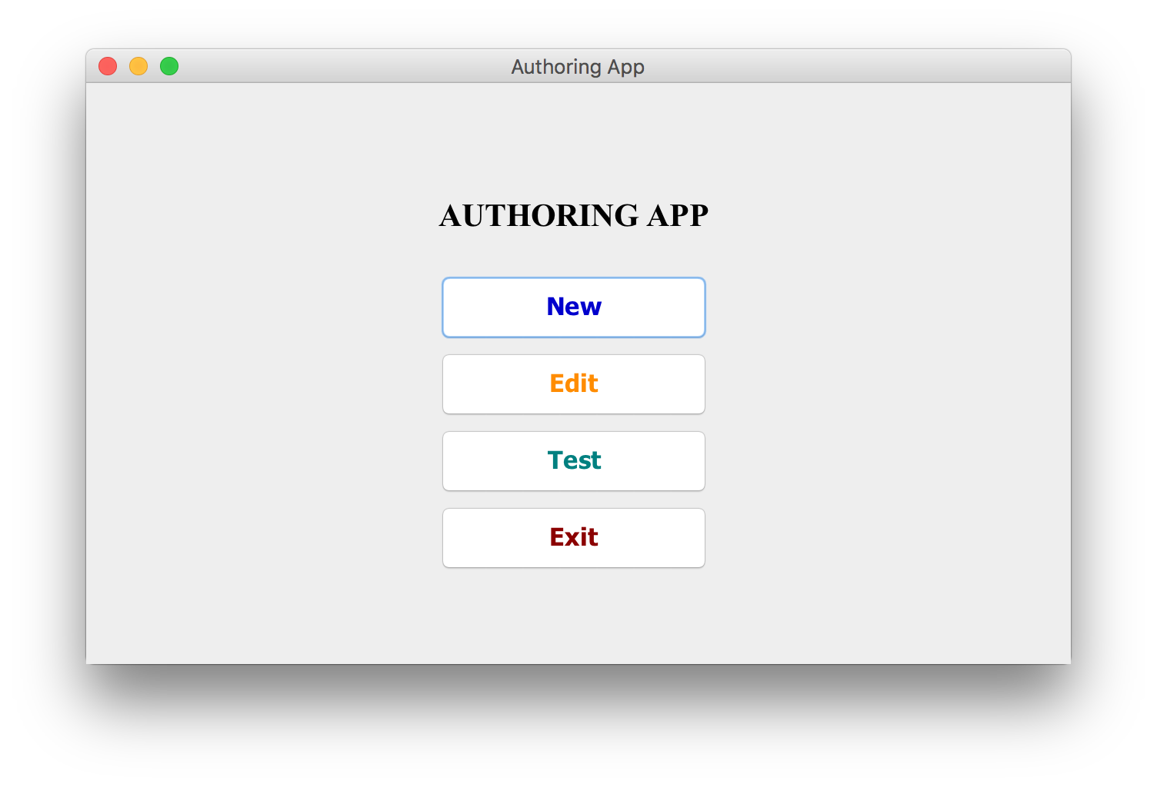

### 

### 3.2. Creating a New Scenario *Shortcut: Ctrl/Cmd + N*

Upon selecting the “***New”*** option, the user will be given a form from which they can select the **Number of Cells and Buttons** for each card, select the **Scenario Title**

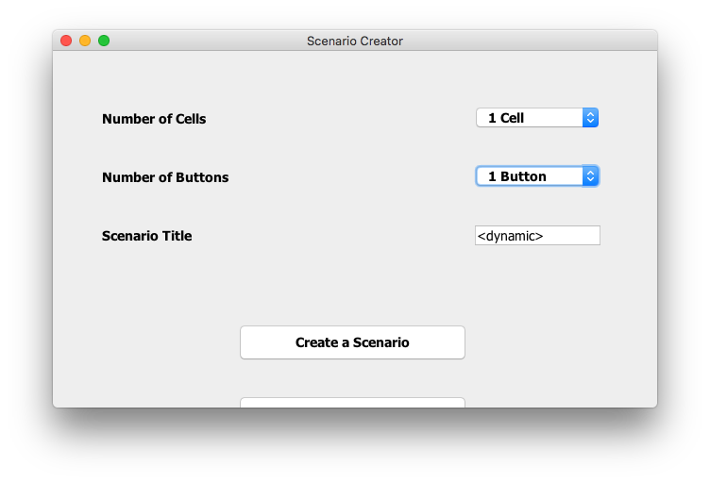

After selecting the details of the scenario, press ***“Save and Create Scenario File”*** to move to the next stage, or ***“Exit Without Saving”*** to return to the main menu.

#### 3.2.1. The Authoring App

Within this window, the user can change the letter to be displayed in the cell, the buttons available to the user and their responses, create or select audio files for the card, and the order the cards shall appear in within the scenario.

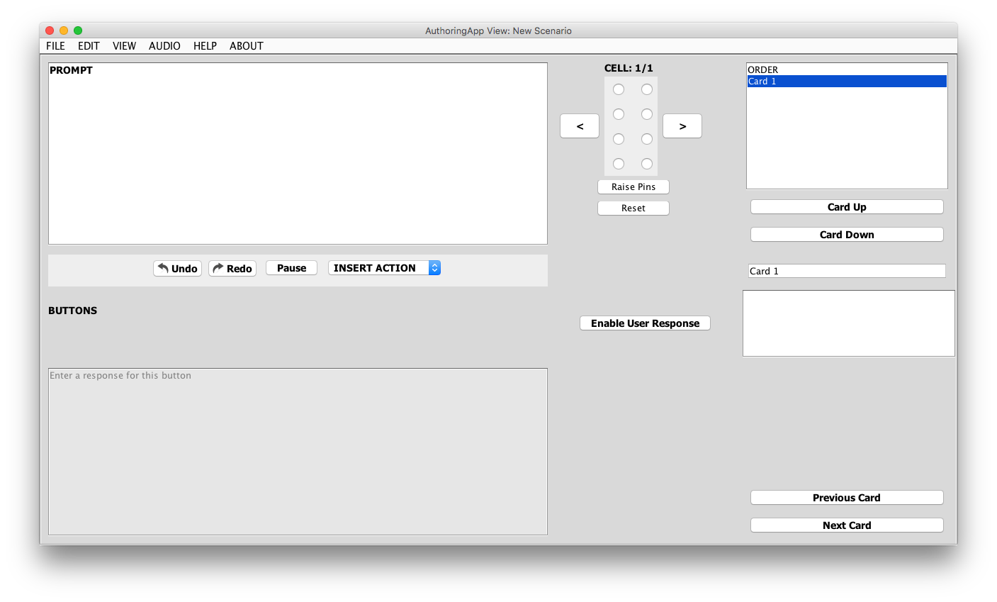

To add new cards, simply press the ***“Next Card”*** button in the bottom right of the window while on the last card within the scenario.

## *Next Shortcut: Ctrl/Cmd + -->*

## *Previous Shortcut: Ctrl/Cmd + <--*

#### 

#### 3.2.2. Prompt

This section of the application is dedicated to the response generated at the beginning of each respective card, from here you are able to prompt the user with statements or questions, enable a pause in the audio, embed an audio clip, or display a set value on the cell.

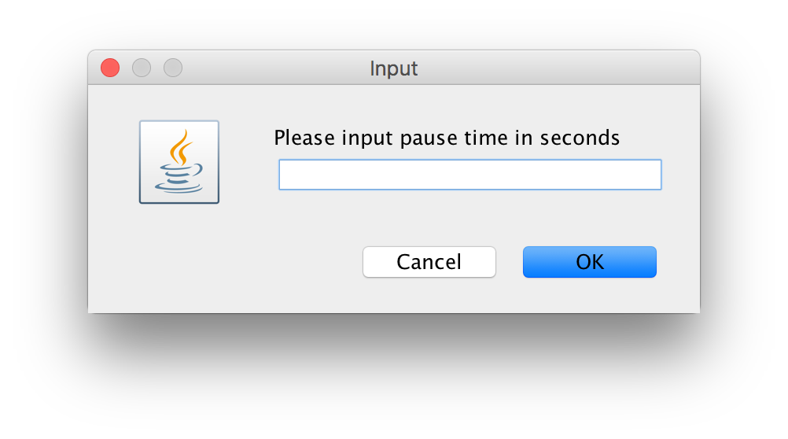

3.2.3. Cells

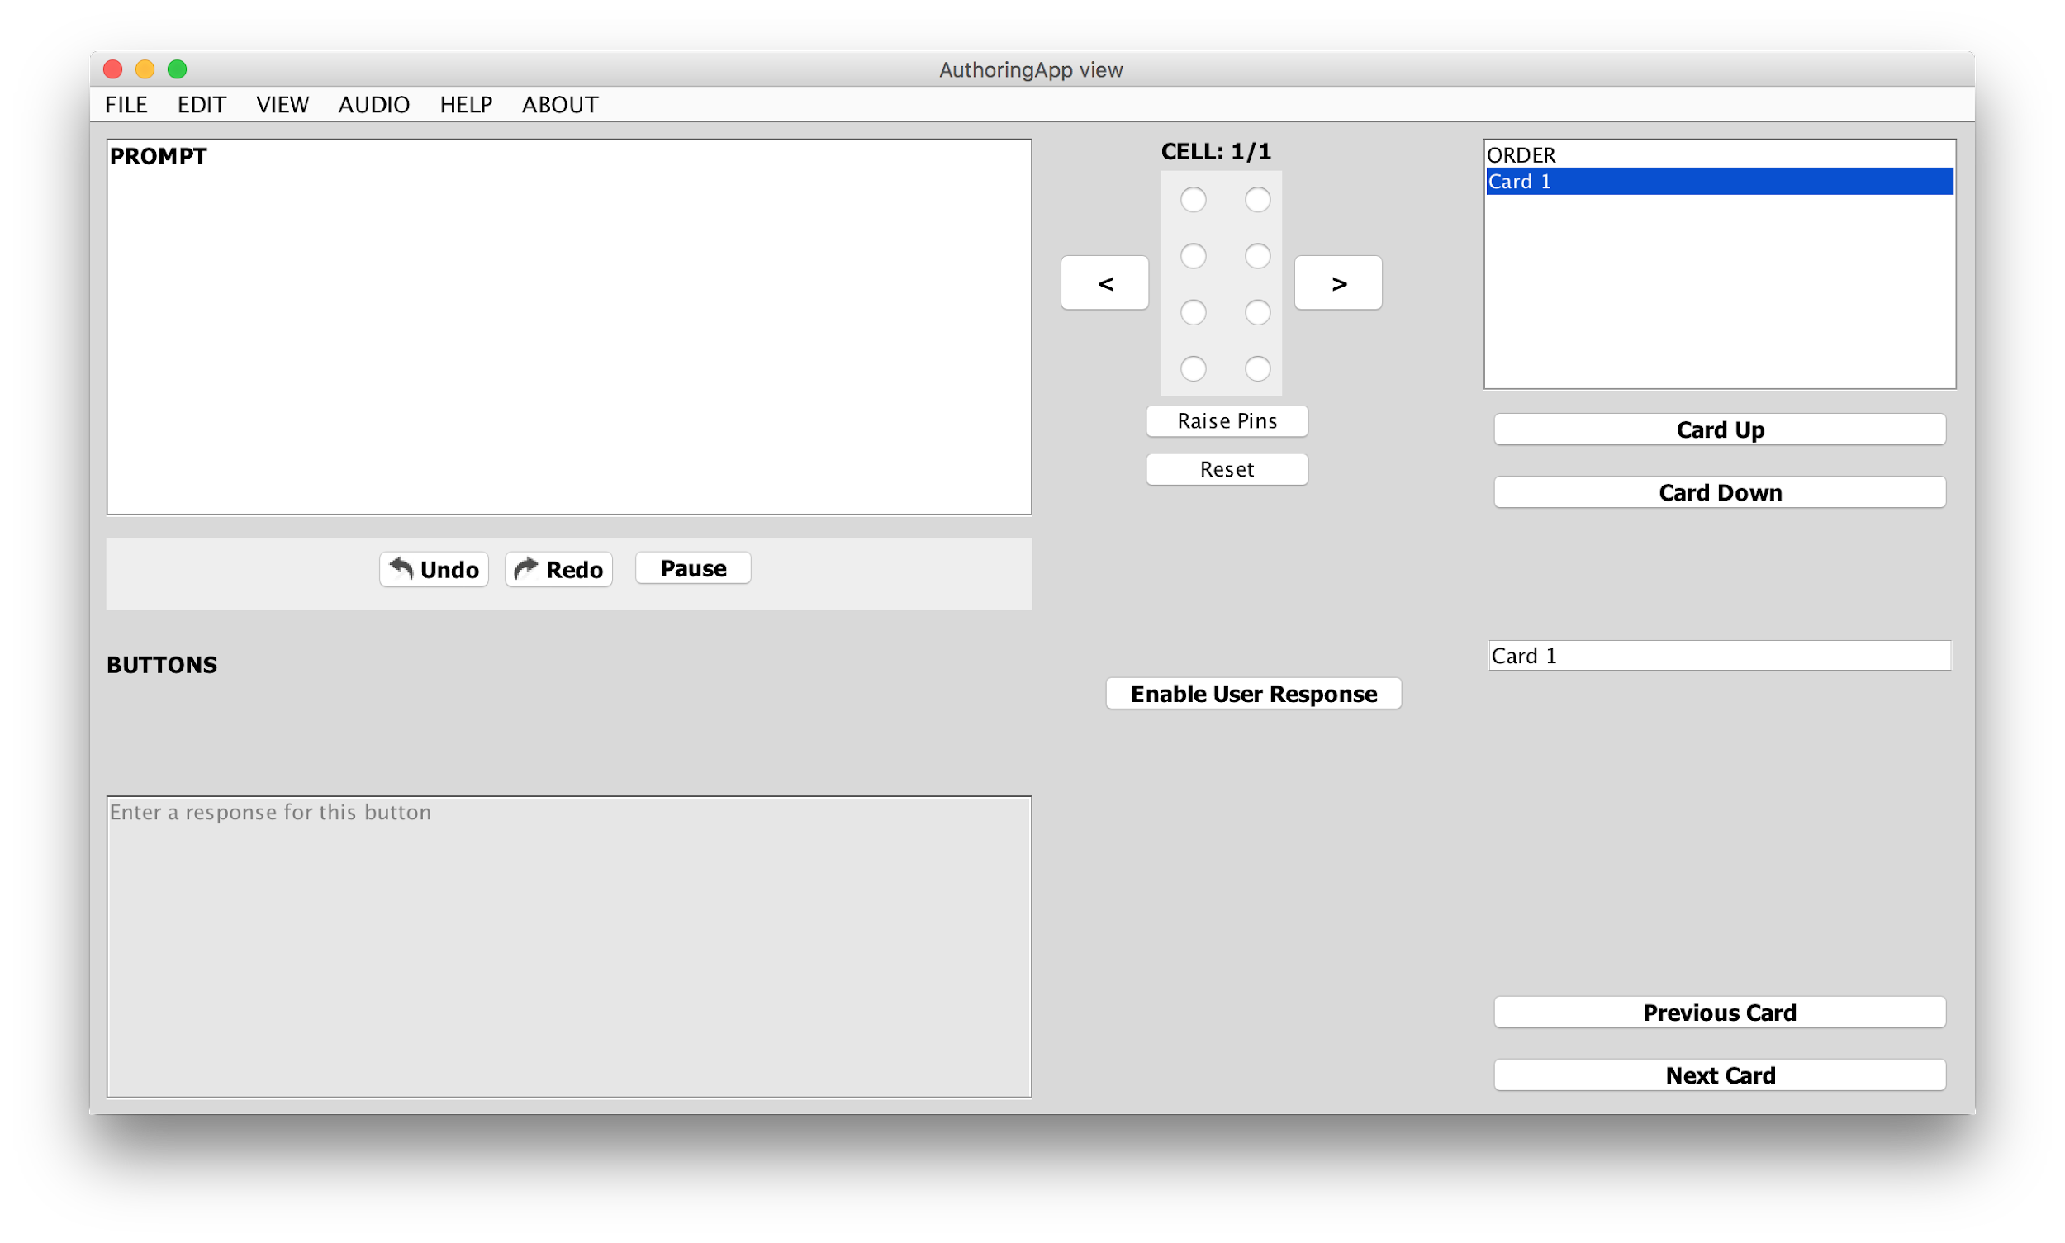

To change the letter to appear within the Braille Cell, the user need only simply select the respective pins to be displayed from this embedded tool, then press ***“Raise Pins”***.

#### 3.2.4. Buttons

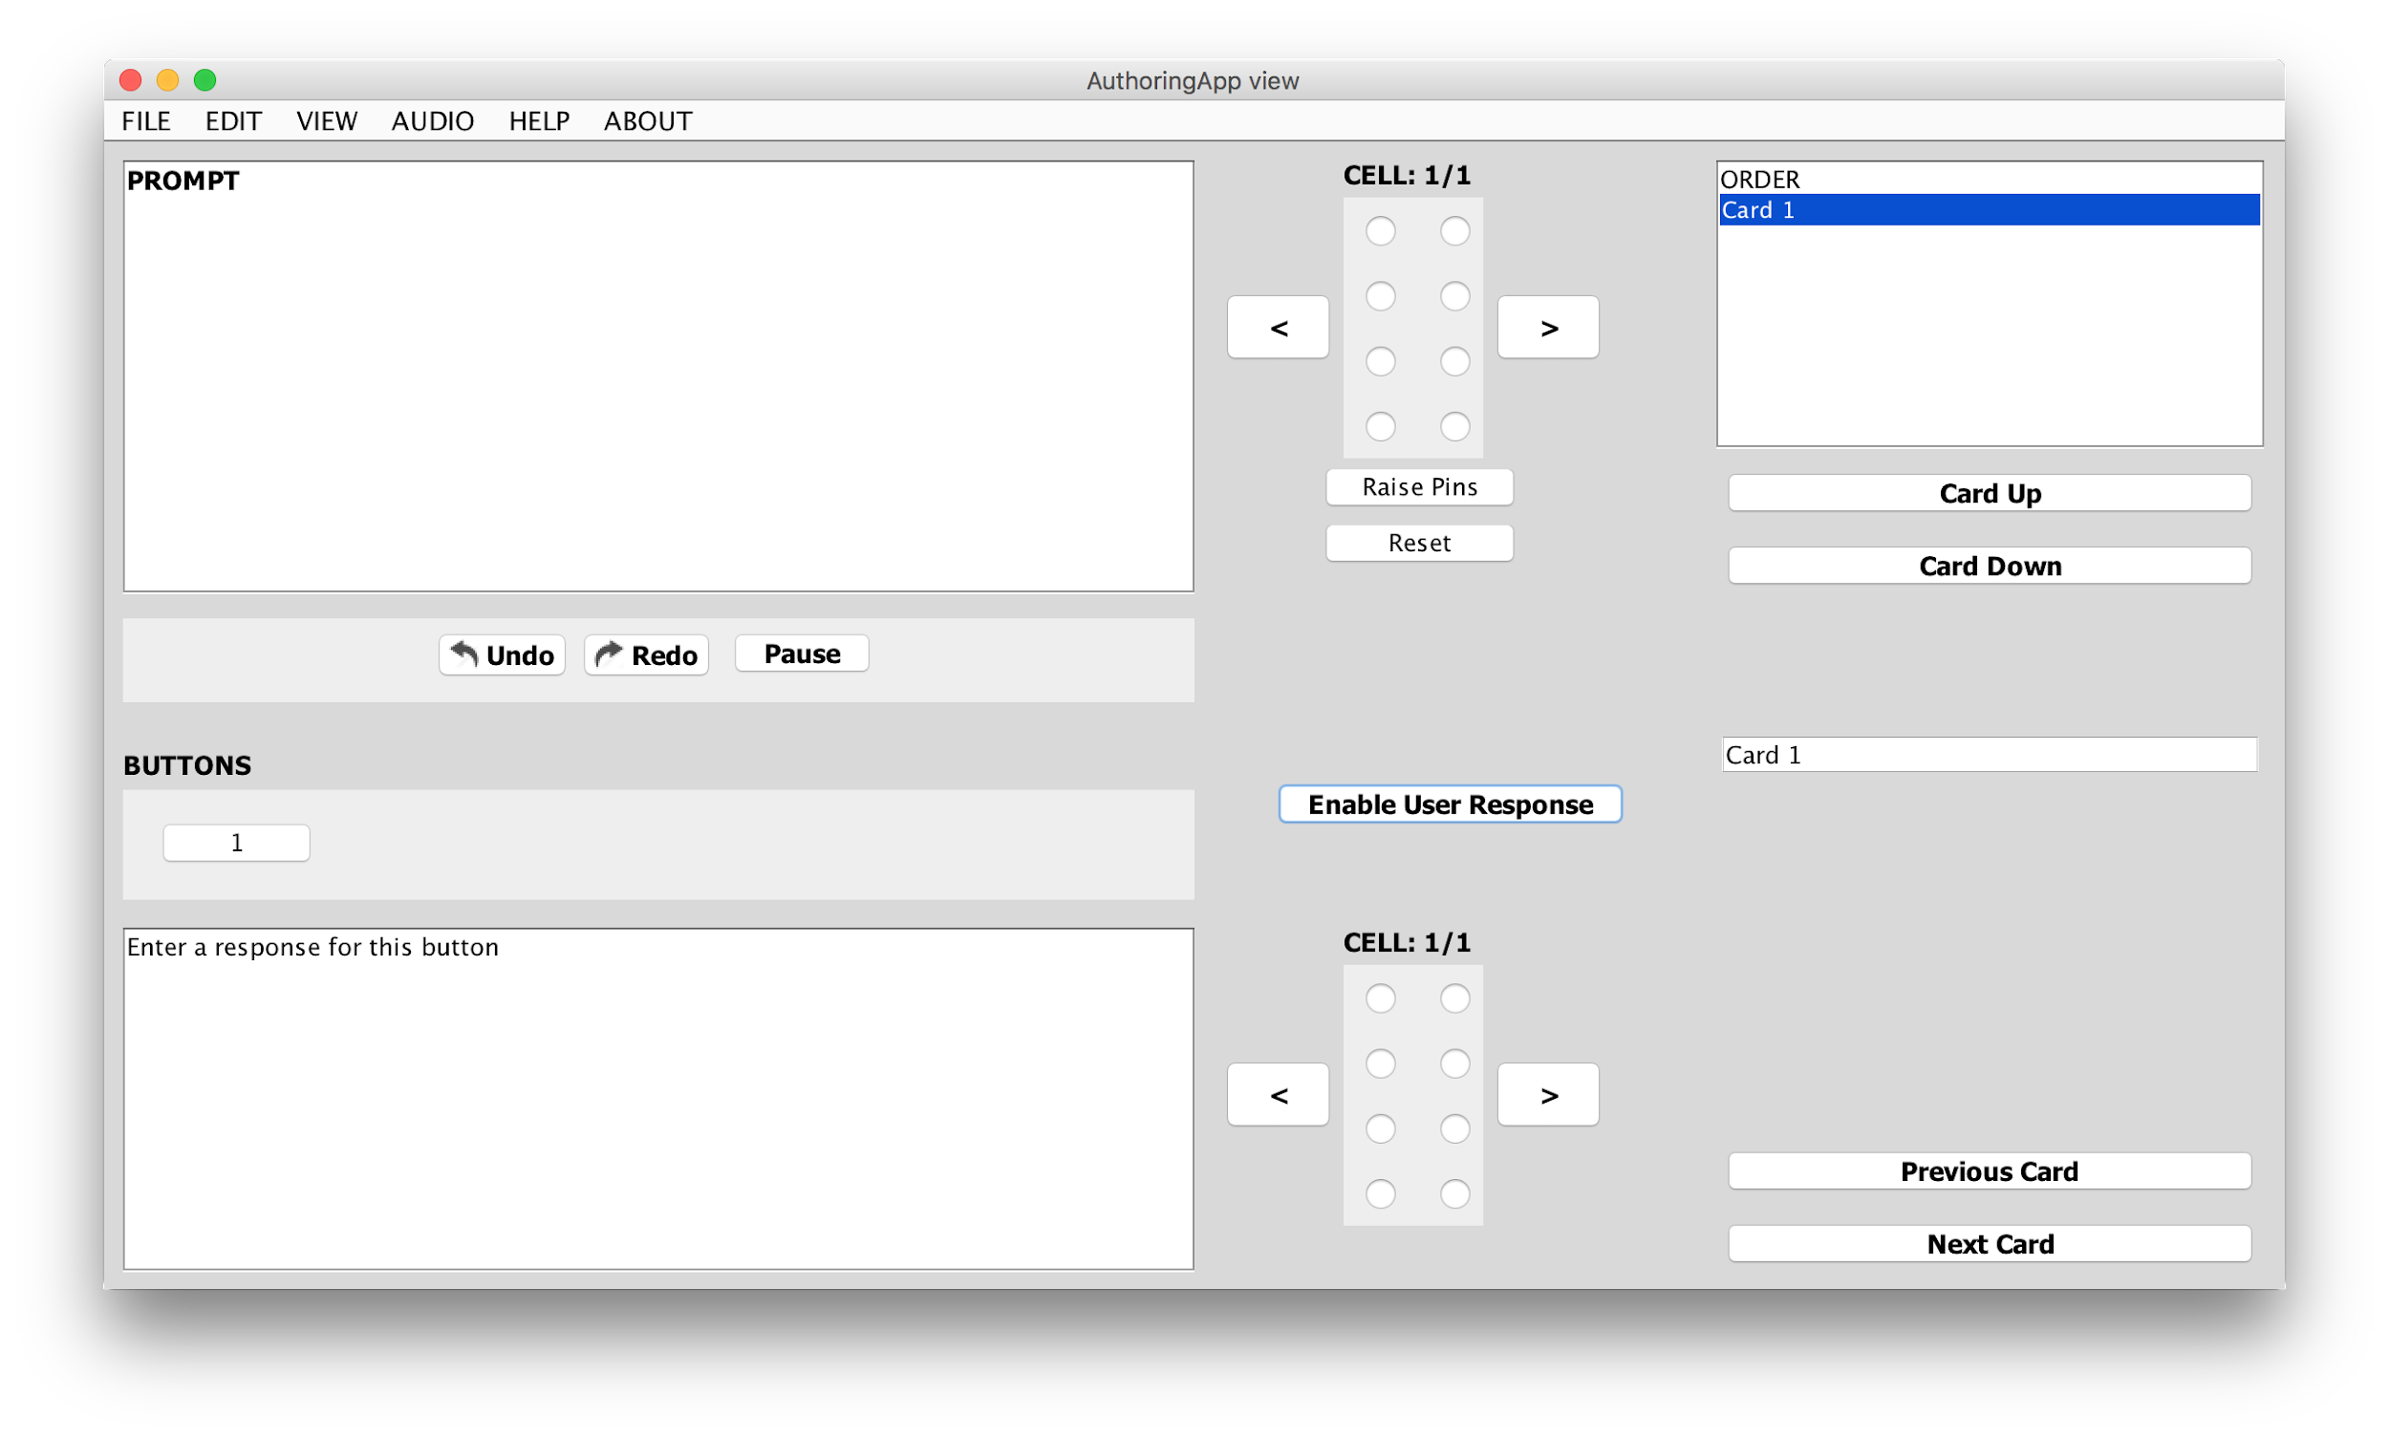

Within this section of the application it is possible for the user to, for each button, create responses to be read within the text box, and allows the user to select the pins to be raised upon click by selecting them on the cell tool located to the right of the prompt.

### 

#### 3.2.5. Editing a Scenario *Shortcut: Ctrl/Cmd + E*

#### 

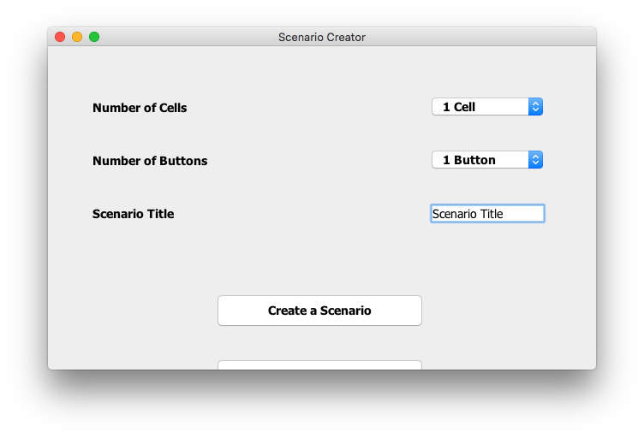

#### To update the current number of Buttons, navigate in the menu bar to the “***Edit”*** menu and select ***“Scenario Form”***, then tweak the values as you chose in the following window.

#### 

#### 3.2.6. Order



This section allows the user to alter the order from which the cards will be presented to the student. To do so, first select the card to be moved from the list, and press the respective ***“Card Up/Down”***buttons as required, or, double click on the desired card.

#### 3.2.7. Audio Recording

To access the audio recording features of the application, navigate in the top menu to the audio tab and simply select ***“Record”*** to launch the recording process.

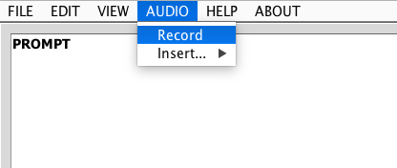

When the user is recording audio, they will be met with the following window, from which they can record audio clips to save for use within their project. This recorder implementation supports the recording, playing, saving, and naming of audio files.

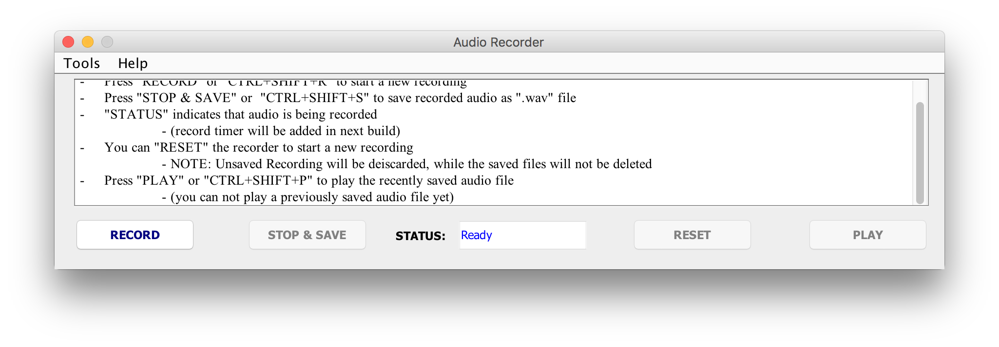

Upon creation of new audio files, there are two ways for you to insert them within your project. Navigating to the ***“Audio”*** section of the menu bar again, but choosing ***“Insert”*** you may then attach the file to be played to a Card or Button response. For ease of access, there is also an alternative quick select within the prompt function dropdown.

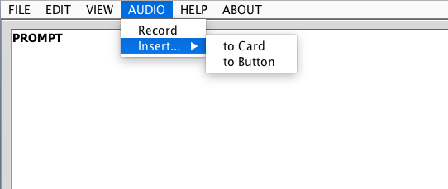

### *To Prompt Shortcut: Alt + P*

### *To Button Shortcut: Alt + B*

## 

## **3.3. Editing an Existing Scenario** *Shortcut: Ctrl/Cmd + O*

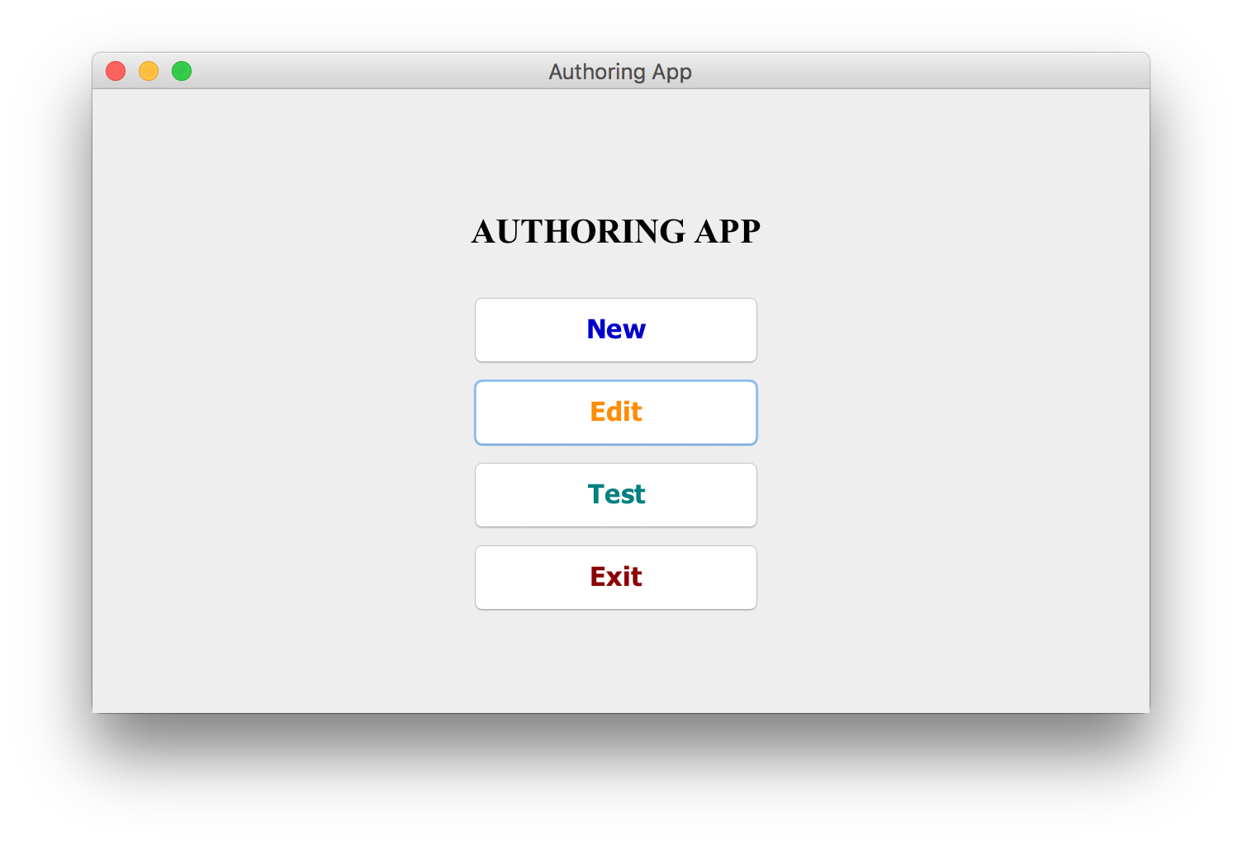

To edit a previously created Scenario, select the ***“Edit”*** option from the main menu, this will launch an iteration of the editing app with the information contained in the selected Scenario available for alteration as necessary.

## 

## **3.4. Saving a Scenario** *Shortcut: Ctrl/Cmd + S*

When finished with the currently worked Scenario, choose the “***File***” option from the menu bar and ***“Save”*** from the dropdown that follows. After saving you’re free to test your newly created scenario, continue working on it, or exit the application.

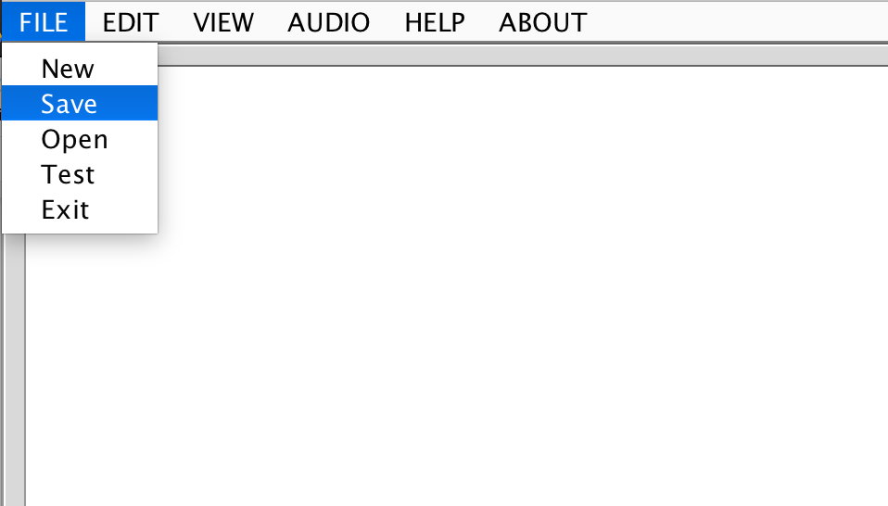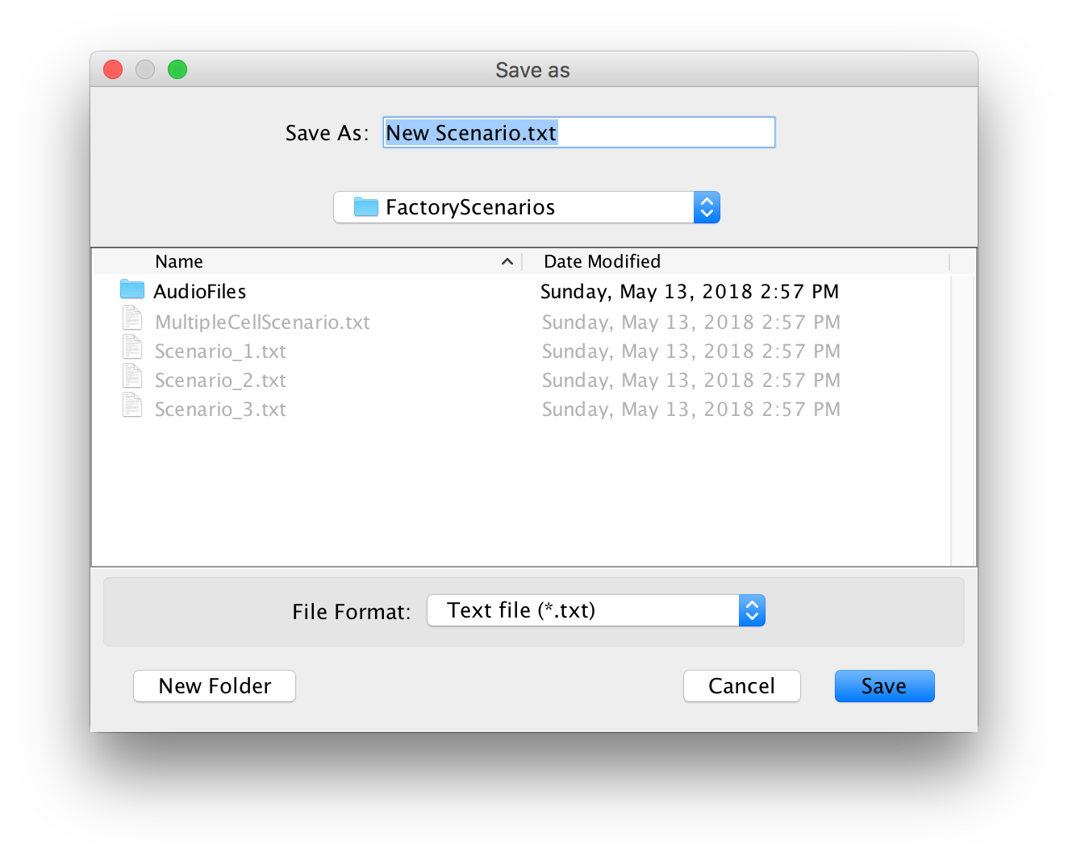

## **3.5. Testing a Scenario** *Shortcut: Ctrl/Cmd + T*

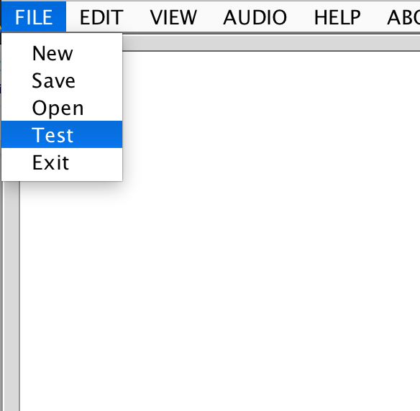

*Or*

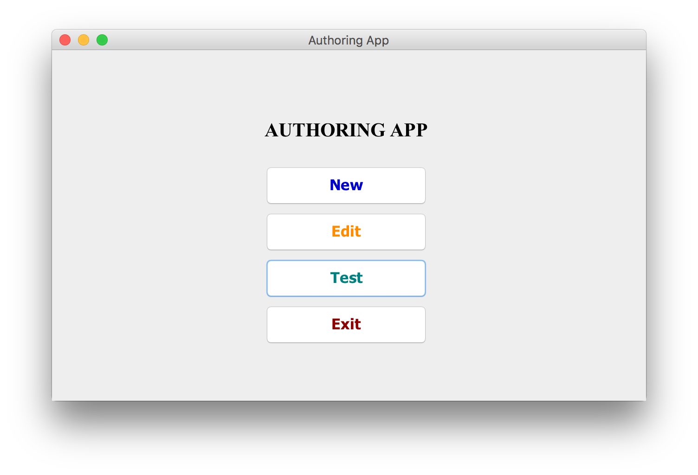

To ensure the users Scenario runs smoothly, there is a provided ***“Test”*** button within both the main menu, and menu bar. To test the created Scenario, first ***save*** the work done, then select this option from one of these windows.

## 

## **3.6. Exiting the Application** *Shortcut: Ctrl/Cmd + X*

The application does **NOT** save your work upon exit, always be sure to have saved your work using the previously mentioned ***“Save”*** button. To exit, navigate to the ***“File”*** section of the menu-bar, and choose ***“Exit”***.

## 

## 

## **4. Keyboard Shortcuts**

|  |  |
| --- | --- |
| **Command** | **Shortcut** |
| New Scenario | Ctrl/Cmd + N |
| Save Scenario | Ctrl/Cmd + S |
| Test Scenario | Ctrl/Cmd + T |
| Edit an existing Scenario *(in Authoring Window)* | Ctrl/Cmd + O |
| Editing the current Scenario | Ctrl/Cmd + E |
| Exit the application | Ctrl/Cmd + X |
| Tutorial Video | Ctrl/Cmd + Shift + T |
| User Manual | Ctrl/Cmd + U |
| Audio to Prompt | Alt + P |
| Audio to Button | Alt + B |
| Github link | Alt + G |
| Course Website | Alt + W |
| Previous Card | Ctrl/Cmd + <-- |
| Next Card | Ctrl/Cmd + --> |

## **5. Uninstallation**

If you wish to remove the application from your computer, simple navigate to the folder containing the application and delete it.

## 

## 

## **6. Troubleshooting**

If experiencing issues in running the program, ensure the program and edition of Java are up to date on the desired computer, and that all required libraries are contained within the same folder as the AuthroingApp.jar file.

**For further inquiries, please contact the developers.**